Ford Motor Company Projects
FIRST PROJECT
Title: Sales, Enterprise Profit Forecasting and Profit Maximization.
Background: I was working for the Marketing and sales team under the BSPA (Business, Sales Planning and Analytics) team. My job was to Collect data from various sources, merge, impute and analyze for any changes since last time to identify the maturity date of data. This was done by comparing 2 consecutive extracts of data and checking the point in time till which the extracts match. That matching date was the maturity of data.

My job was to forecast sales and suggest strategies to optimize (maximize) profit for the upcoming quarter by analyzing at marketing letters shared by the sales and marketing teams of the UK market, performing optimization and forecast as mentioned in details later. This helped the business prepare for their GtM meetings. The UK was the most difficult market of all because of the complexity of models and due to difficulty to please customers.
Objectives of the project:
- Forecast monthly sales of a ford vehicle (mine was Ford Fiesta) for the next quarter
- There was a FCE model (aka FCE Penetration model)- Called the Ford Credit model. It was a multinomial logit model which predicted probability of a customer opting for a financing option while buying a ford vehicle. Typically, this was called FCE Penetration or the Finance penetration. This was always more than 95% for the UK market and most likely near 98%.
- There was the booking model. The booking model took the customers who were predicted by the FCE model to opting for Financing, and would split them into which financial instrument they opted for. This was a discrete choice model - Nested Logit model. UK had 8 Financial Instruments. There were 3 nest for the nested logit model. Each finance option was classified in terms of the option (Ford Options, Ford Acquire, Ford Cashplan) and also the term length of the Finance loan (this was the time over which the customer would pay the instalment) - 24, 36 or 48 months.
The most opted for one was Options 36 months - with a near 36% probability and Options 48 months - near 35 percent probability. Others were less.
- The last model was for sales forecast - also called the demand model. The sales was calculated for:
1. Each Trim of Fiesta (6 trims) - one trim is a variant of the vehicle (fiesta is a nameplate which had 6 trims - Active, ST, STLine, Titanium, Vignale, Zetec). We used a Generalized Nested Logit to forecast sales for each of the trims and divided the trims into nests for the Generalized nested logit model with similar vehicles belonging to the same nest / cluster.
2. This forecast was made for 4 filters of the data:
- Employee Renewals
- Retail Renewals
- Employee Conquests (first time employee purchases)
- Retail Conquests (first time retail customers)
3. This made a total of 6 * 4 = 24 forecasts. 4 Generalized nested logit models were trained overall - all 4 of them were trained to predict the same 6 trims, only for different subsets of the data.
- So, the overall process was:
1. Forecast sales for 24 effective trims for fiesta (24 = 4 * 6) using the generalized nested logit (GNL) - this is a vector forecast accounting for cross-substitution.
2. Now, use the FCE model to forecast the fraction of customers opting for Financing. This makes 2 * 24 = 48 (24 finance + 24 cash upfront) forecasts total.
3. Now, each of the Financing customers were split into 8 categories by the Nested Logit model (booking model) - this is done for each of the customers opting for finance. This makes 24 * 8 = 192 forecasts
4. So, the total number of forecasts made were 192 + 24 = 216
- Now, we recalibrated the demand model. That meant to tune the intercept of the model to adjust its value to accurately predict the demand value in the last few months. This tunes the model to the recent demand shifts in the market. How many months to use was my decision - I made that decision in the following way:
1. Did some new change happen in the recent months that I want the model to capture? For example, did the business team launch a new finance option? In that case, I want my model to calibrate itself to the new level of demand that happened due to that change. - that is when I would run optimization again - but this time, only optimizing the intercept of the model - and on the few months of data that I want the model to learn from. This happened when the business removed the 48 month financing option. We didnt know how the market share would change for the different financing options. There were 8 before - now only 7. So, we had 2 ideas - one was to map all the options 48 customers to options 36 or the second option was what we did - was to wait for one month of data - where the market adjusted to the lack of options 48 option - and recalibrate the intercepts of the model (that included the intercepts of the booking model) on this new one month of data. Remember, recalibration only optimizes the intercepts. So, the model most likely did not overfit. But this approach worked.
2. Another example is if I want the model to respond to new competition - recalibrating on months when the new competition came to the market
3. Recalibration loss function also included the % error function - this was an indirect way to include a difficult loss function in my model. Using just the % error as a loss would be difficult because it is a difficult loss to optimize. So, the primary loss was MSE loss and only the recalibration loss was this log % error loss
This loss also included the error made in the booking model - this is the only part of the model training when the 2 separate models (booking and GNL) talked to each other - well their intercepts talked to each other.
- Then, something called Typical Customer data was calculated. This typical customer data could be calculated with any granularity. Typical customer data was averages of variables over certain historical periods - which was taken carry forward for the next quarter. This was basically data which we wanted to forecast but could not forecast - so we just took the average of the latest few months of data as a proxy for forecast. How many months to average? That depended on which of the last few months was an accurate representation of the coming months.
Why was typical customer calculated? → Because it was used in profit calculations for the next 3 months. The Sales numbers were taken from the forecast models. And other quantities which were used in the profit calculations, were taken from the typical customer average.
Example variables for which typical customer average was computed are: Dealer Incentives (This is the extra amount that a dealer gets for selling a vehicle - this variable did not govern sales in the UK but it was an important predictor of sales in France), Equity value - which represents the cash value received for an old vehicle that can be received in the market.
- Then, the Enterprise profit is calculated. Here is how it was calculated: Profit = Revenue - Costs
Revenue = (List Price - Discount) * Sales forecasted by the model
Costs = Material Costs
Profit = Revenue - Costs
- Now, this profit was maximized as a function of Incentives - 4 variables - Deposit Allowance (this is the discount given on the initial deposit for FCE Customers), APR (annual Percentage rates - this is the interest paid by the customer on the monthly instalments), Other Cash (this is trade-in allowance * fraction of customers who are expected to opt for trade in), Privilege (this is the discount given to Employee customers). Each of these variables is there for 216 trim granularities - as shown earlier, making it a total of 216 * 4 = 864 decision variables.
- Bounds and constraints:
A. Bounds: FCE Penetration must be within +- 20% of baseline. Also, all decision variables are constrained to be within +- 20% of their baseline values
B. Constraints: APRs of higher months (48) is always supposed to be larger than lower months(36 M) which is larger than 24 months APR. 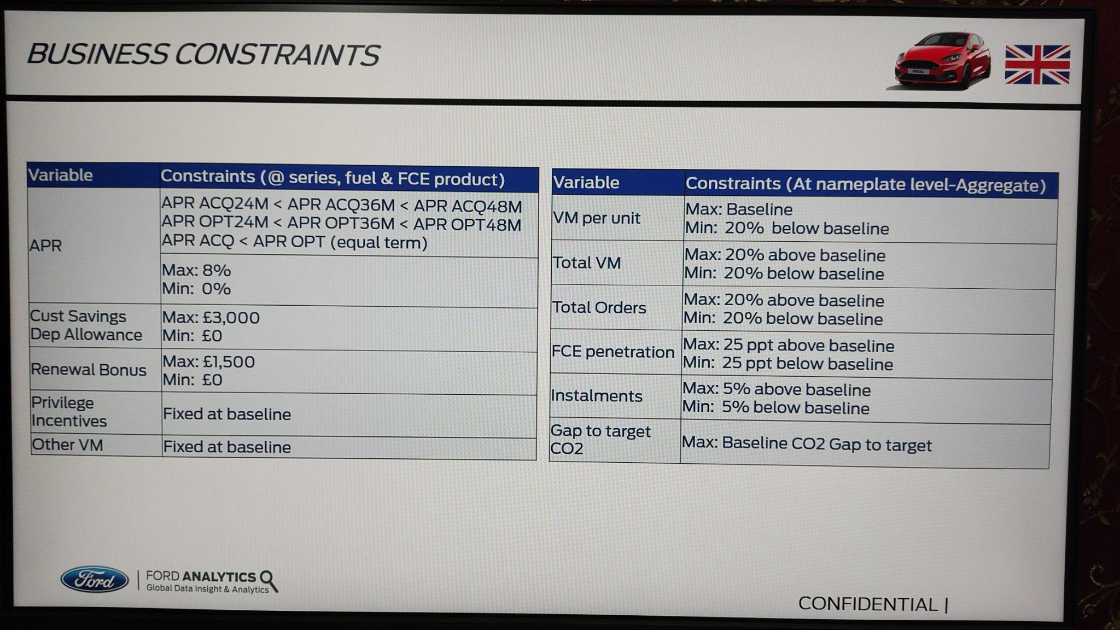
- The Optimization method used was SQP in MATLAB - and PSQP / IPOPT in python.
- Then, the results of the forecast are presented to business folks, summarized with historical forecasts and % errors. We always claimed to have 10% error max
- There was something called perfect fit - which was used to remove some data points from data - like covid. These points are harmful to fitting the model - and is hence, important to remove. Another time when data is removed, is 1 - 3 months after the launch of a new trim or facelift. This is because generally, after a new launch, for the first few months, the demand can be a bit unstable Due to the pent up demand from the previous months.

Standard problems we solved in this project:
- New Launches: Perfect fit for the next 1-3 months after launch, Indicator for the demand level after 3 months - to let the model adjust to the new demand level for the new launch
- Pent up orders: Orders which could not be fulfilled by the company - due to low stocks. Then, apparently for the next few months, the excess orders taken will be passed on to - registered to the next months. So, we will have an excess number of orders in the next few months. To compensate for this, we take the difference between the forecast and actuals for the history - this history is the number of orders not fulfilled - which will be fulfilled in the future - so, we add that difference in the future.
- Removal of Finance option - This happened when the business removed the 48 month financing option. We didnt know how the market share would change for the different financing options. There were 8 before - now only 7. So, we had 2 ideas - one was to map all the options 48 customers to options 36 or the second option was what we did - was to wait for one month of data - where the market adjusted to the lack of options 48 option - and recalibrate the intercepts of the model (that included the intercepts of the booking model) on this new one month of data. Remember, recalibration only optimizes the intercepts. So, the model most likely did not overfit. But this approach worked.
- They (business) introduced a change in the deposit allowance. Previously, the Deposit Allowance was the same for all term lengths of financing (of monthly instalments). However, for this case, they set the deposit allowance of 36 months to 1000 and zero for the other months. This had never happened. So, The model over-predicted the share of the 36 month contracts. To fix this - I had to adjust the constraints over the parameters - which corresponded to the coefficients of the Cash Equivalent APR of the 36 month choices.

